DoD Government Convenience Checks
What Is & Is Not Reportable on IRS Forms 1099

IMPORTANT: Convenience Check data may fall under the Privacy Act of 1974, as amended, 5 U.S.C. 552a. Protect it.

Information based on
- IRS Publication 525 Taxable and NonTaxable Income;
- 2020 Instructions for Forms 1099-MISC and 1099-NEC Miscellaneous Income and Nonemployee Compensation
- IRS Form W-9, Request for Taxpayer Identification Number & Certification
- Form W-8 BEN Request for Taxpayer Identification Number & Certification
- IRS Publication 515 Withholding of Tax on Nonresident Aliens and Foreign Entities
- IRS Publication 901 U.S. Tax Treaties

PURPOSE

To assist with capturing vendor information for inclusion in the spreadsheet that will be provided to the Convenience Check Writer, APC, and Account Manager from the DFAS ESS Tax Office.

To assist with understanding which government convenience check data is taxable income that requires IRS tax form issuance and IRS electronic reporting.

IMPORTANT TO KNOW

Monthly, the DFAS ESS Tax Office obtains the universe of DoD convenience check payment data for the prior month from U.S. Bank. The Tax Office then emails a spreadsheet to the responsible agency employees requesting additional information be added to the spreadsheet for vendors and payments determined as tax reportable.

IRS has resurrected IRS Form 1099-NEC and redesigned IRS Form 1099-MISC. Starting tax year 2020, all payment amounts previously reported in Box 7, Nonemployee Compensation of the Form 1099-MISC will now be reported in Box 1, Nonemployee Compensation of the Form 1099-NEC.

The federal government must issue 1099-MISC or 1099-NEC to corporations whereas the commercial world does not. This confuses corporations. Corporations believe they are exempt from tax form issuance and IRS reporting when, in fact, they are not exempt.

The Tax Office determines the dollar threshold for issuing the tax form by aggregating all like vendor convenience check payments.

CAPTURE VENDOR INFORMATION

Use an IRS Form W-9 or W-8 BEN

IRS recommends using IRS Form W-9 or W-8 for capturing vendor information. A new W-9 or W-8 is required when any vendor information as registered with the IRS changes. It is a good practice to obtain a new W-9 or W-8 annually.

IRS Form W-9, Request for Taxpayer Identification Number & Certification
Before issuing a check to a U.S. Vendor, Individual, or Resident Alien, ask them to complete a W-9. The information listed on the W-9 is used for issuing tax forms to vendors whose payments are identified as requiring a tax form. The W-9 is also maintained by the Convenience Check Writer for audit purposes.

Information required from the vendor includes:

- Vendor or Individual’s Tax Identification Number (TIN). The TIN is always nine numbers; no alpha characters; no nine sequential numbers
- Legal name of the vendor or individual. The legal name is the name used when the vendor or individual files their taxes. This name should match what the IRS has on file for the vendor or individual.
- Legal mailing address.

The IRS has a video to assist with completing the IRS Form W-9: https://www.irsvideos.gov/Business/Resources/HowToCompleteFormW-9

Backup Withholding

If the vendor or individual refuses to provide their information, the IRS mandates withholding 24% from the payment and depositing with the IRS.

IRS Form W-8BEN Request for Taxpayer Identification Number & Certification

Think twice before issuing a convenience check to a foreign individual or foreign vendor. The Convenience Check Writer is responsible for any tax withholding requirements and tax deposits due to the IRS. Perhaps paying using the miscellaneous payment procedures would be a better option. Miscellaneous payments are made for non-recurring, non-contractual purchases. Additional information on Miscellaneous Payments can be found in the DoD Financial Management Regulation, Volume 10, Chapter 12.

Before issuing a check to a foreign individual or foreign vendor, ask them to complete the applicable W-8. Most will complete a W-8BEN, which is appropriate for the majority of foreign individuals and sole proprietors who earn money from U.S. sources.

Determine if there is an IRS reporting requirement by identifying whether the income is U.S. source income. Go to the IRS website Nonresident Aliens - Source of Income https://www.irs.gov/individuals/international-taxpayers/nonresident-aliens-source-of-income for Factor Determining Source.

If there is a reporting requirement (the payment is to foreign individual or vendor for U.S source income), the check writer must determine if there is an amount of tax to be deducted and withheld from the payment and then deposited with the IRS.

To determine the tax withholding amount, consult IRS Publication 515 Withholding of Tax on Nonresident Aliens and Foreign Entities, Tax Treaty Tables at https://www.irs.gov/individuals/international-taxpayers/tax-treaty-tables, and Publication 901 U.S. Tax Treaties.
INFORMATION FOR ISSUING TAX FORMS

The DFAS ESS Tax Office will provide a spreadsheet to the Convenience Check Writer, APC, and Account Manager monthly with the universe of check transactions the U.S. Bank processed. Specific columns on the spreadsheet for the check transactions need completed in order for the Tax Office to issue tax forms on the responsible agency’s behalf.

If the vendor is a federally tax-exempt entity or the payment is determined not tax reportable, the Tax Office needs the Convenience Check Writer to complete the following columns on the spreadsheet:

- Payment Description. A description of what was paid for with the check.
- Yes or No Reportable Transaction: No, the transaction is not tax reportable.

If the vendor is not a federally tax exempt entity and the payment is determined tax reportable, the Tax Office needs the Convenience Check Writer to complete the following columns on the spreadsheet:

- Vendor’s Taxpayer Identification Number. This can be an SSN, EIN, or ITIN.
- Vendor’s Name. This is the legal name of the vendor or individual as registered with the IRS.
- Vendor’s Address. This is the vendor’s current mailing address
  - Vendor’s Address Street
  - Vendor’s Address Apt/Suite
  - Vendor’s City
  - Vendor’s State
  - Vendor’s Zip Code
  - Vendor’s Country
- Payment Description. A description of what was paid for with the check.
- Yes or No Reportable Transaction. Yes, the transaction is tax reportable.
- The dollar amount placed in the appropriate Category field.
  - Check paid for Rents, Rentals, Leases
  - Check paid for Royalties
  - Check paid to individual for participating in a medical research study
  - Check paid for Medical/Dental Services
  - Check paid for Services by vendor or individual not an employee
  - Check paid for Attorney Fees

THE CATEGORY

The Category determines which box the money is placed in on the IRS Form 1099.

Non-Employee Compensation (Services)

This is the column on spreadsheet titled, Check paid for Services by vendor or individual not an employee.

.

Dollar amount is reported in Box 1 of the Form 1099-NEC.

Most services reported are Non-employee Compensation. Non-employee means a merchant or individual who provides services for the government, is paid by the government, but is not considered an employee.

Examples of Non-Employee Compensation service payments are:
- Services and the parts or materials used to perform the services if supplying the parts or materials was incidental to providing the service. An example would be changing oil in a vehicle. The oil and filter are incidental to providing the service so the service amount and the amount for the oil and filter are all reported.
- Maintenance and repairs to office machines, buildings, equipment.
- Maintenance to lawn or vehicle.
- Installation or repair of electrical, telephone, or cable services.
- Personal, professional, and technical services including advertising, consulting, appraisals, architectural, auditing, accounting, computer programming, cleaning, engineering, laundry, or copying.
- Priest or Minister services.
- Playing the piano at church service or choir director.
- Attorney fees for legal work, legal adjudicators, witness fees.
- Notary fees for a notary to notarize a document or payment for an employee to become a notary.
- Instructors, teachers, trainers. This includes vendors who administer tests.
- Providers of conferences, registration fees.
- Honoriums, speakers
- Entertainers
- Privately owned colleges & privately owned universities
Note: Go to website https://www.univsource.com to determine if a college or university is public or private.

Rents
This is the column on the spreadsheet titled, Check paid for Rents, Rentals, Leases.

Dollar Amount reported in Box 1 of the Form 1099-MISC

Examples of Rent payments are:
- Renting booths or tables from a non-tax exempt entity.
- Renting parking spaces.
- Renting equipment or tools.
- Renting boats, cars, buses, etc.
- Renting coin operated amusements including video games, pinball machines,
jukeboxes, pool tables, slot machines, or other machines operated by coins.
- Renting ranches for military maneuvers.
- Payments for advertising.

Royalties
This is the column on the spreadsheet titled, Check paid for Royalties.

Dollar Amount reported in Box 2 of the Form 1099-MISC

Example of Royalty payment is:
- Royalties such as those paid directly to an author or literary agent including copyrights and publishing rights.

Other Income (does not include services)
This is the column on the spreadsheet titled, Check paid to individual for participating in a medical research study.

Dollar Amount reported in Box 3 of the Form 1099-MISC.

Example of Other Income is:
- Payment made to test subject/individual for participating in medical research study.

Medical and Health Care Payments
This is the column on the spreadsheet titled, Check paid for Medical/Dental Services.

Dollar amount reported in Box 6 of the Form 1099-MISC.

Examples of medical and health service payments are:
- Privately owned or funded hospitals and extended care facilities.
- Doctor, Physician, Dentist, Veterinary fees and charges.
- Physician Assistant or Dental Assistant fees and charges
- Medical and dental payments for examinations.
- Medical tests.
- Medical Boards, which include payments for research fees or payment
for an employee to register or join a specific medical board.
- Prevention, diagnosis, treatment, or management of disease or illness.

NOT REPORTABLE

The below information does not encompass all non-taxable types of payments or entities.

Type of Payment
Do not report the check data if the payment was made for any of the below payment types:

- Credit or travel card payments. The local banks issue the IRS Forms 1099-K for credit card and travel card payments starting tax year 2012 for 2011 payments.
- Merchandise, products, or goods.
- Bank fees.
- Stamps, postage, payments to the U.S. Postal Service.
- Pharmacies for prescription drugs
- Churches
- Utilities such as electric, gas, water, fuel oil, coal, bottled gas, & other fuels; telephone & cell phone services, & cable. Installation is reportable; the utility itself is not.
- Small package transportation and small delivery services such as Federal Express, UPS, and DHL
- Safety deposit box, considered storage
- Warehouse Storage, considered storage.
- Magazine or newspaper subscriptions.
- Internet or computer renewal license.
- Payment to a company to be bonded.
- Informer payments for information about criminal activity.

Type of Entity
Do not report the check data if the payment was made to one of the below entity types:

- Federal tax-exempt organizations or agencies such as VFW Posts, American Legion, Red Cross, etc.
- Government agencies (federal, state, city, county, parish).
- State owned (funded) colleges, community colleges, and universities
- High schools, Grade schools.
- Hospitals owned & operated by the United States, State, or the District of Columbia and any of their subdivisions. Charitable hospitals (To verify an organization’s exempt status use the IRS Exempt Organization Select Check at https://apps.irs.gov/app/eos/
- Federal tax-exempt organization memberships to clubs, organizations, societies such as ASMC.
- IRC 501(c)(7) exempts from federal income tax, clubs "organized for pleasure, recreation, and other nonprofitable purposes, substantially all of the activities of which are for such purposes and no part of the net earnings of which inures to the benefit of any private shareholder."
- Social clubs or organizations that are membership organizations, whose majority of income is not dependent on public sources. See IRC 501(c)(7) for further explanation. Organizations which may be described in IRC 501(c)(7) include, but are not limited to:
- College fraternities (See Rev. Rul. 69–573, 1969–2 C.B. 125, and Rev. Rul. 64–118, 1964–1 C.B. 182).
- Private country clubs
- Private amateur hunting, fishing, tennis, swimming and other private sport clubs.
- Private dinner clubs, which provide a meeting place, library, and dining room for members.
- Private variety clubs
- Private hobby clubs (See Rev. Rul. 66–179, 1966–1 C.B. 139).
- Private community associations (See Rev. Rul. 69–281, 1969–1 C.B. 155, and Rev. Rul. 80–63, 1980–1 C.B. 116).
Normally, an organization’s exempt status can by verified by using the IRS Exempt Organization Select Check at https://apps.irs.gov/app/eos/. Another way to verify the organization’s status is to ask the organization to provide a copy of their IRS ruling or determination letter (tax-exempt status letter). This is a letter issued by the IRS stating the organization is approved as federal tax exempt.

Other resources about tax exempt entities:
- Exemption from tax on corporations, certain trusts, etc. https://www.law.cornell.edu/uscode/text/26/501
- Exempt Organization Types
https://www.irs.gov/charities-non-profits/exempt-organization-types
- Tax Exempt Organization Search
https://www.irs.gov/charities-non-profits/tax-exempt-organization-search
- UnivSource: Determine if a college or university is public or private.
https://www.univsource.com

END OF THE CALENDAR YEAR

The Tax Office aggregates the tax reportable convenience check payment data for “like vendors”. This includes data from the Army, Navy, Air Force, Marine Corps, DFAS, and DLA. If the total payment amount is $600 or more, a tax form is issued and mailed to the vendor before January 31. The Tax Office then electronically reports the payment information to the IRS.

The Tax Office will provide a report of the payments that resulted in tax form issuance to the Convenience Check Writer and APC. The Convenience Check Writer should maintain this report for audit purposes for at least four tax years.

EXAMPLES OF TAX FORMS

IRS Form 1099-NEC
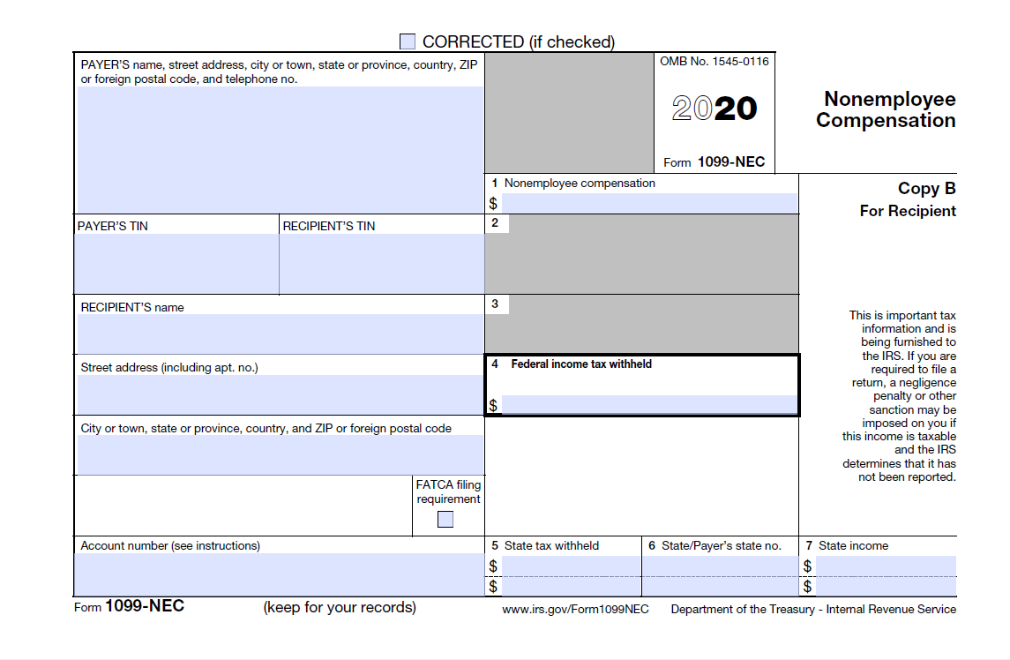

IRS Form 1099-MISC
